# Selenium IDE Testing – Listing Textbooks

This testing scenario includes the listing a textbooks for our textbook sharing website. We are going using the selenium program to test whether each user story is able to meet their acceptance criteria.

The acceptance criteria for Listing Textbooks are:

* Add new book listing to the website.
* New book is added to the database.
* Remove existing book listing.

To list a textbook as a user, you must do the following steps:

1. Go to <http://bookbook.azurewebsites.net/bookbook/pages/homepage.php> and login as a user
2. Once logged in click ‘List a Book’ button on the toolbar
3. Enter in the details for your textbook
   1. All fields must be filled in for book listing to be successful
   2. However, the book edition and cover image are optional
4. Once all details are input click on the ‘Submit Query’ button
5. If all details meet the requirements a green pop-up text will read “Book successfully added.”
   1. If details are not input correctly a red pop-up text will read “Title and author required.” (See Figure 2)
6. Once you receive the green pop-up text, your textbook has been successfully been added to our database

As seen in Figure 1, it shows Selenium program testing our case for Listing a Textbook. It captures each of the above steps and is able to run through it all without any failures.

Mentioned earlier is the acceptance criteria for this user story, and it has three criteria that must be met for this user story to be successfully implemented. Figure 1 shows the automated testing of the first two acceptance criteria, and Figure 3 shows the website interface of executing them:

* Add new book listing to the website.
* New book is added to the database.

Figures 4 & 5 respectively shows the exactly the same thing as before, but for the last acceptance criteria:

* Remove existing book listing.

Although there was one problem I discovered during this test, it occurred when selecting an option to list the condition of the book. In Figure 6, you can see you are given 3 options: Brand New, Slightly Worn and Well Worn. In this instance I chose Brand New, however when I searched for my book in Figure 7 it displays a different condition name under ‘new’. This is a minor problem and will be fixed by the end of the 2nd release.

# APPENDIX

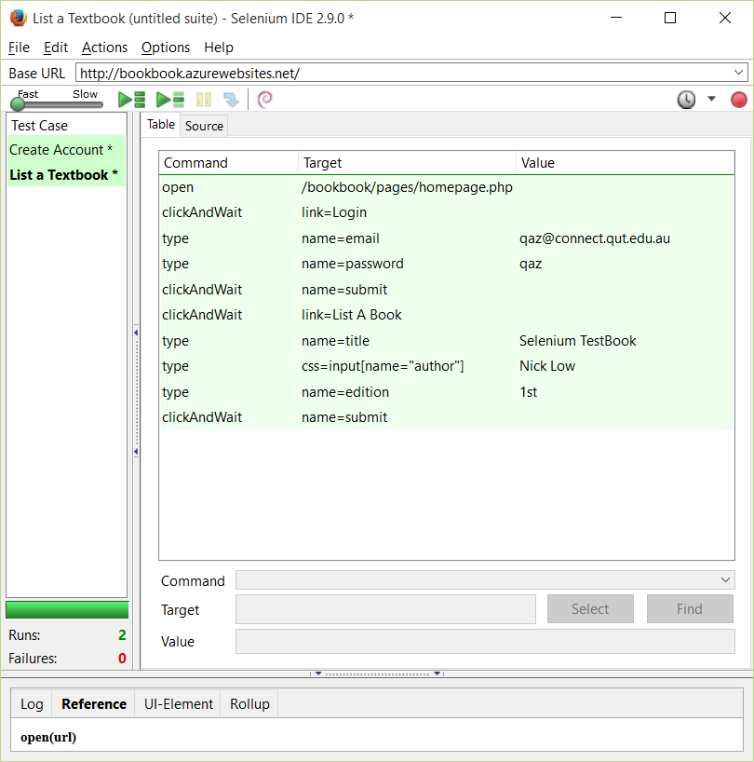

Figure 1

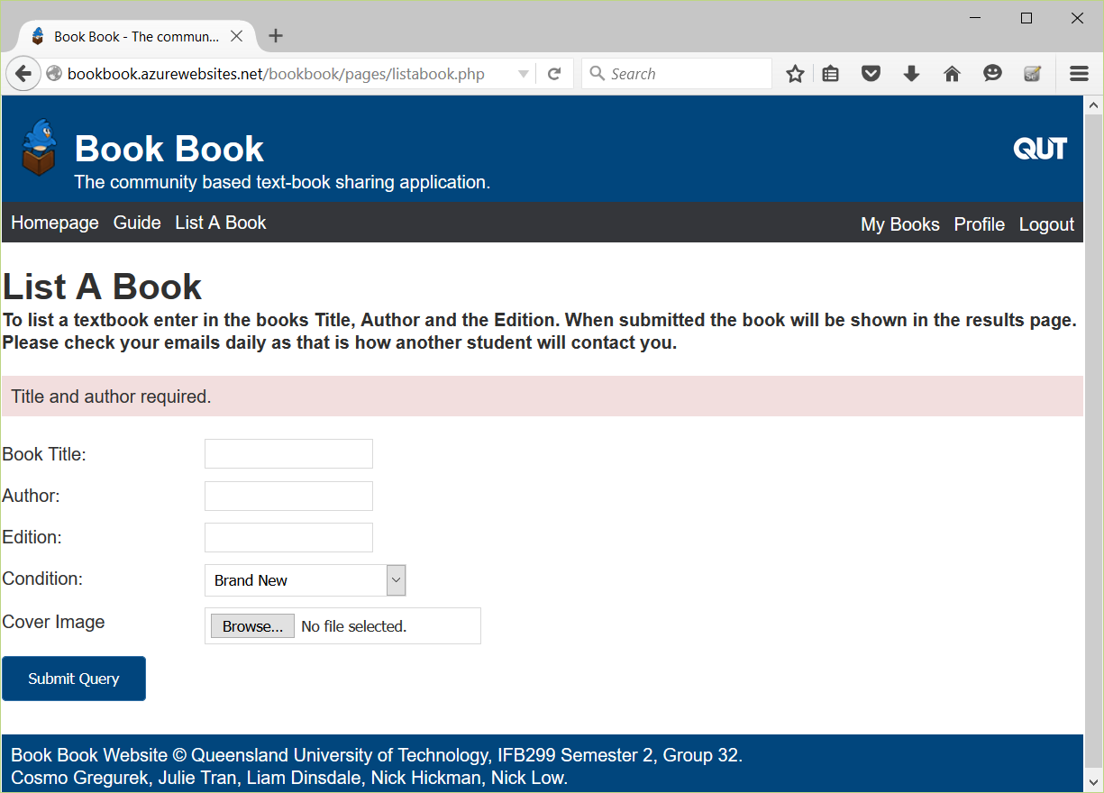

Figure 2

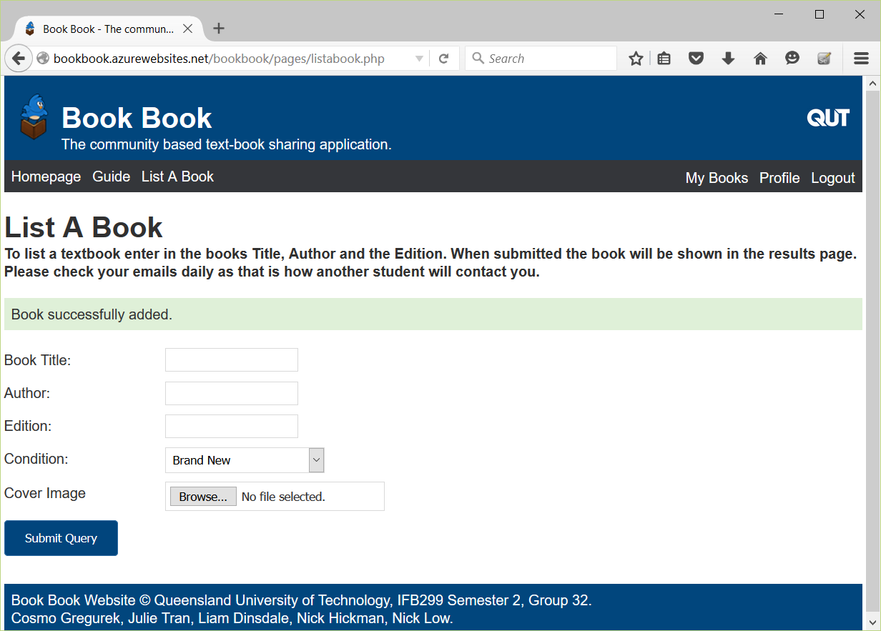

Figure 3

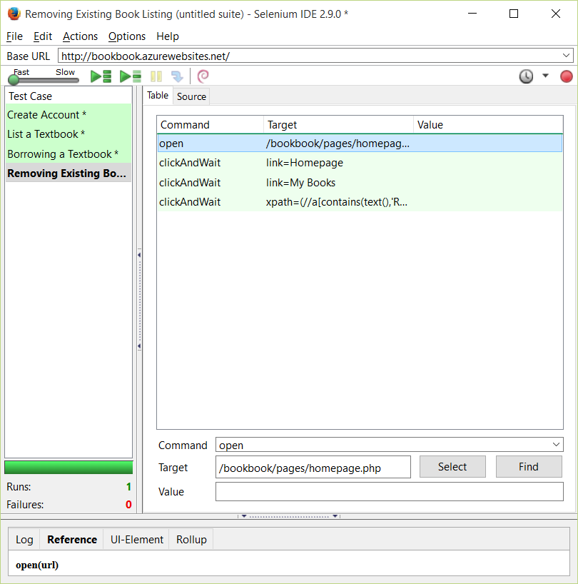

Figure 4

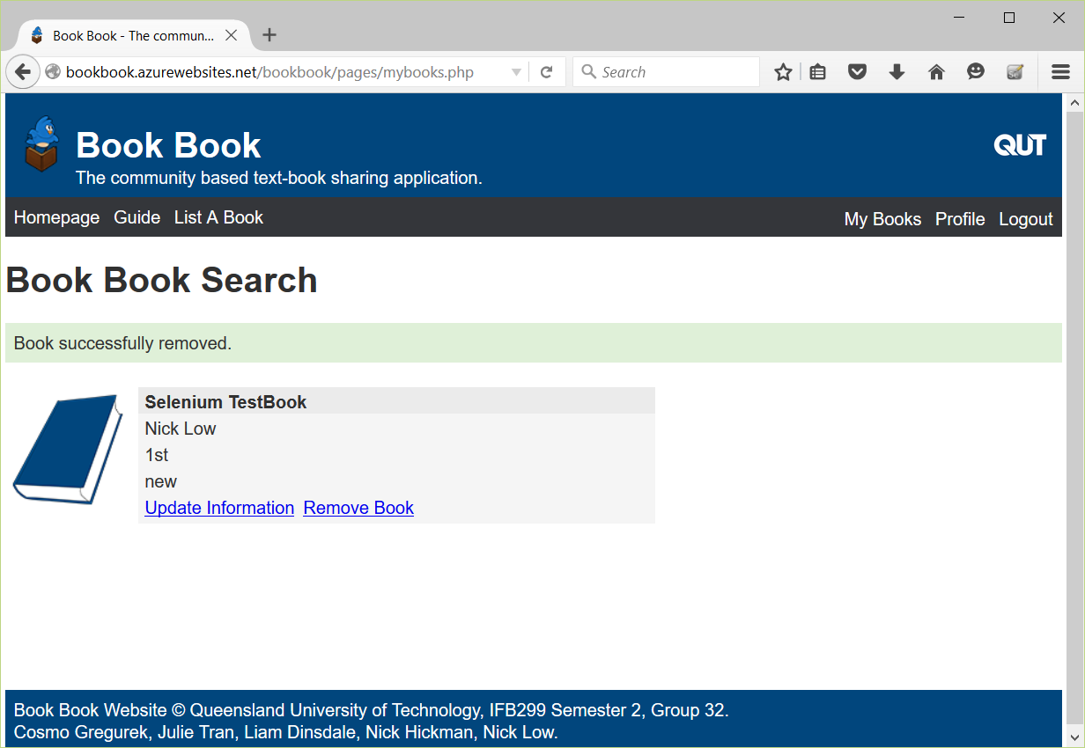

Figure 5

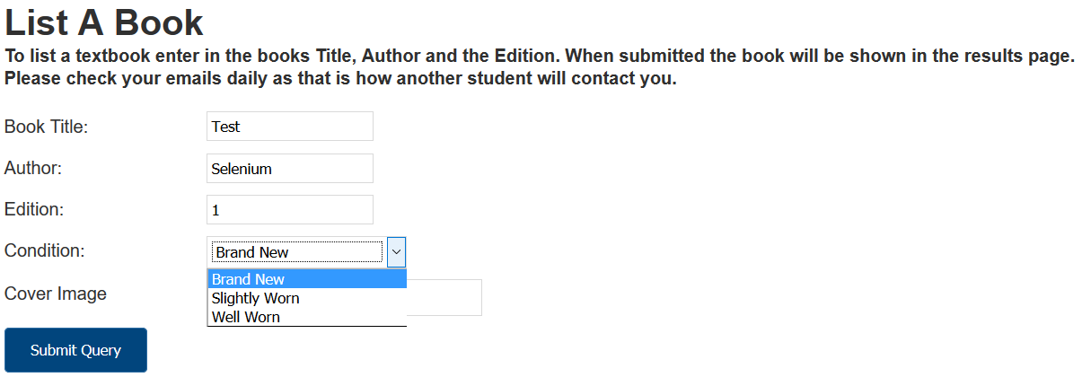

Figure

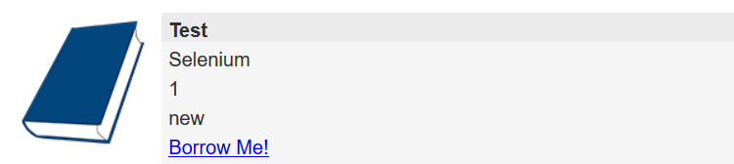

Figure